Dynamic Configuration in GitHub Actions

The problem is very simple:
How do we create a value in one GitHub Actions step and use that value in the next step?
(BELOW LAB WILL NOT WORK ..LETS UNDERSTAND WHY)
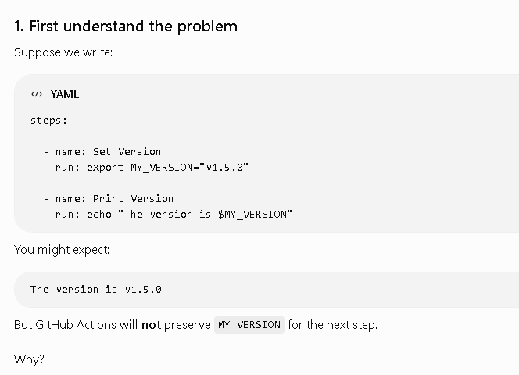
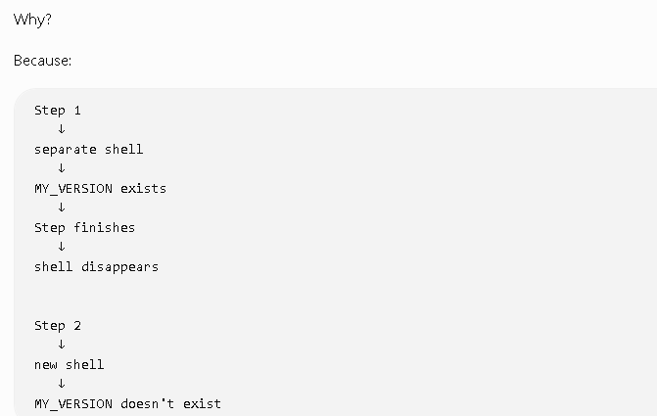
2. Solution: $GITHUB_ENV
GitHub provides a special environment file:
$GITHUB_ENV
We can write a variable into it:
echo "MY_VERSION=v2.0.0" >> $GITHUB_ENV
## In the same GITHUB REPO
Create another workflow:
workflow-call-lab
│
└── .github
└── workflows
├── reusable.yml
├── main.yml
└── dynamic.yml NEW

.github/workflows/dynamic.yml
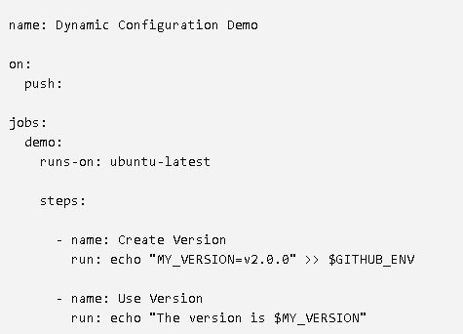
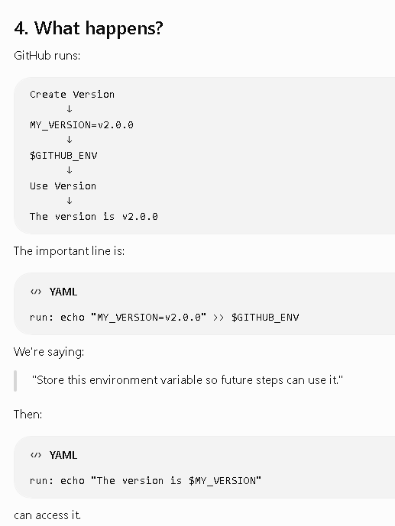
## Create one more workflow
github.run_number
name: Dynamic Configuration Demo
on:
push:
jobs:
demo:
runs-on: ubuntu-latest
steps:
- name: Generate Version
run: |
DYNAMIC_VERSION="v1.0.${{ github.run_number }}"
echo "MY_VERSION=$DYNAMIC_VERSION" >> $GITHUB_ENV
- name: Display Version
run: echo "Deploying version $MY_VERSION"

